2015 November 13

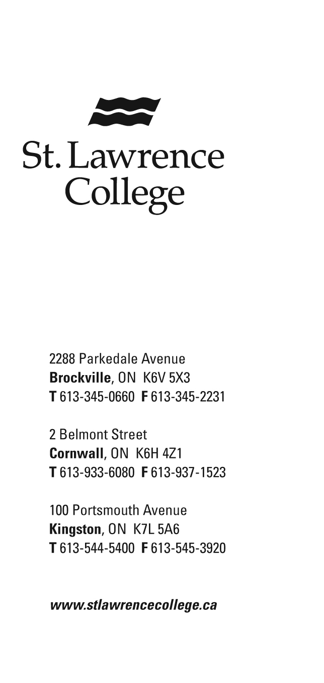
Barbara Nayler, CHIM (C)
Placement
Health Information Management Program
St. Lawrence College (Kingston)

Catherine MacDonald, Program Assistant
Quality Improvement Decision Support, Governance and Leadership Programs
Association of Family Health Teams of Ontario

Dear Family Health Teams:

Thank you for your consideration in becoming a placement site for a student in the Health Information Management Program at St. Lawrence College (SLC). Your consideration in providing practicum experience to the students enrolled in the Health Information Management diploma program would assist the College, the students and the Healthcare community in developing the technical and business skills the students will need to be competent and competitive in the field of health information management.
In 2012 the Canadian Health Information Management Association (CHIMA) published its final report titled ‘Transforming Health Information Management: The Evolution of the HIM® Professional’. This report summarized the findings of two workforce studies conducted in collaboration with the province of Alberta and other information agencies such as COACH, CIHI, Canada Health Infoway and the Information Communications and Technology Council (ICTC) plus many others. A full copy of the report can be found at the following link: https://www.echima.ca/media/documents/Workforce%20Transformation_FINAL_WEB.pdf .

As identified in the above report, healthcare is rapidly moving into the digital world and while most agree that healthcare will be greatly improved for both the client and the management of the system, the fact remains that lack of trained health information professionals, technologists and managers, may impact how well and how fast we are able to meet the goal of an electronic health record. (CHIMA, 2012, p. 9)

In response to the rapidly evolving healthcare environment, the Canadian College of Health Information Management (CCHIM) introduced new curriculum in 2010. Changes to the course content were made to address the need for professionals who not only understand the management of the health record and its information, but who can also work equally well in the electronic health record world, assisting in the design and implementation of EHR’s, database management, data collection, analysis, reporting and protection of privacy. A summary of the areas of study listed in the CCHIM Learning Outcomes and the SLC courses which students must pass with a minimum 63% average is attached in Appendix A.

The St. Lawrence College HIM Program is one of only 4 in the province of Ontario. In 2009 the SLC program changed its format from the typical 2 semester, 2 year delivery timeline to 12 consecutive months, while increasing its didactic, lab and placement hours to meet the new learning outcomes. Although this has resulted in a very intensive program, we are meeting a need in the community for individuals who have previous work experience and postsecondary education wishing to enhance their education in order to find employment in the health care field. Many of our students have post-secondary diplomas or degrees with a few possessing Masters or Doctorate degrees but are unable to find work in the Canadian system in their chosen professions. This change in the program timeline has also allowed us to provide graduating students to the many organizations who are seeking HIM professionals in a shorter timeframe. Our program has recently received a 5 year accreditation from the Canadian College for Health Information Management in the new 2010 curriculum.

Each semester students must complete a practicum session to provide them with an opportunity to work in an actual health care setting in which they can apply their recently acquired knowledge.

Due to the increasing numbers of students, we are attempting to locate placement partners for the first and third semesters closer to the students’ home locations. Previous to this, most of the first and second practicum hours have been provided by Kingston area health facilities. With increasing enrolment, this is becoming very difficult. We are therefore extending our search for placement partners to other areas in the province and Quebec.

First semester site placements are currently planned for the third week in December. If we are successful in finding facilities close their home, this will allow the students to be home as we move into the holiday season. The practicum consists of 4 days (Monday to Thursday) for 8 hours per day on site at the partnering facility. The objective of this placement is to provide students with the opportunity to observe the complete cycle of information within the health care facility through the following phases:
- the collection of personal health information (registration, MPI maintenance, data entry or completion of paper forms in health care areas)
- qualitative and quantitative analysis and records QA processes (chart collection, review, deficiency flagging etc)
- chart processing (assembly, scanning, chart tracking)
- coding and data submission process
- distribution of information including dissemination to other levels of care, release of information and reporting (administrative and decision support) and
- privacy.

Hands on experience is not required and sites are asked only to evaluate the students on professional behavior, attentiveness, appropriateness of questions and willingness to assist with any clerical functions that they may be able to complete. Many of the students have little to no perception of the health care industry prior to the start of this semester and the aim is to have them become more aware of the flow of information into and out of the health care facility.

Third semester practicum is for 6 weeks from the first of July to the second week in August. Students are expected to complete 240 hours of placement, however in order to meet the busy demands of many placement hosts, students may be placed for any combination of 2, 4 or 6 weeks based on the availability of tasks and supervision during this time. Some sites with large projects may request multiple students who can work together as a team or individually on separate assignments. While on placement, students are expected to spend a normal workday at the placement site and adhere to rules and regulations as set down by your organization. We encourage practicum sites to provide an orientation to their organization so that the students can appreciate their role in the context of the overall function. Placement partners are encouraged to interview interested students to ensure that the student is a good fit for their organization. Students must complete a major project which they will present to the faculty and fellow students following their placement. We will work with you to select a project which will be suitable for the student and the placement site. It is expected that students will be able to perform at the same level of expertise and efficiency as any entry level HIM professional.

The expectation is that the placement will be beneficial to both the host organization and the student and therefore any function which allows the student to assist the facility in various areas while enhancing their knowledge gained at school would be a valuable experience. As Anton Chekhov stated “Knowledge is of no value unless you put it into practice”.

The following is a suggested list of tasks the student could perform at the placement facility during their summer practicum.
- Privacy Office requests or investigations.
- Requests from third parties for patient information (Release of Information)
- Requests from internal parties for information for quality assurance, risk management or research.
- Work flow analysis
- Data collection and input
- Coding of emergency, clinic, cancer care, or inpatient records using Canadian coding standards and ICD10-CA and CCI.
- Reception/registration and management of the Master patient Index.
- Quality assurance and error correction of data entered into the electronic health record or abstracting system
- Collating patient information for the patient referral process
- Compile statistics and/or research
- Policy and/or procedure review or development for health information practices such as document standardization, forms cataloguing and design, deficiency processing, or records destruction and chart retention protocols
- Literature searches for policy and procedure development

Please note that this is a list of suggestions. We realize that your organization is very busy and we sincerely appreciate the time you and your staff will take in mentoring the student(s) should you accept the practicum.
If you have any questions or concerns about any of the requirements or processes related to the placement experience, please do not hesitate to contact either Jane Piribauer or myself at any time.

Thank you for considering our students for a placement in your organization. We look forward to working with you in the near future.

Yours very truly,

Barbara Nayler, Placement
613 544-5400 Ext 1330
bnayler@sl.on.ca
Fax: 613-545-3915

Megan Bailey CHIM, Coordinator, HIM Program
613 544-5400 Ext 1159
mbailey@sl.on.ca
Fax: 613-545-3915

Works Cited
Canadian College of Health Information Management. (2010). Learning Outcomes for Health Information Managment. London: CHIMA.
Canadian Health Information Management Assocition. (2012). Transforming Health Information Management: The Evolution of the HIM® Professional. London, CHIMA.

