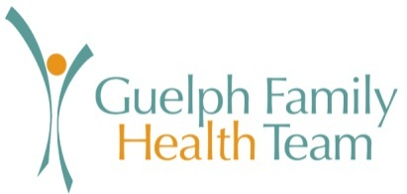

CATEGORY: Human Resources POLICY NO. : GFHT2012003
SUBJECT: WHMIS: Workplace Hazardous Materials Information System PAGE(S): 1
APPROVED BY: Executive Director, Ross Kirkconnell DATE: Jan. 31, 2012
GFHT Board Chair, Steven Traplin
_____________________________________________________________________________________________

PURPOSE:
GFHT is committed to providing an effective Workplace hazardous Materials Information System (WHMIS) to protect employees, contractors, students, clients and visitors when they are working with or exposed to potentially hazardous materials on company premises.

SCOPE:

WHMIS exemplifies the employees ‘right to know’ about possible workplace hazards which is enforced under the Occupational Health & Safety legislation.

This system includes:
- Labels – To identify types of hazards as a precaution.
- MSDS – Provides access to Material Safety Data Sheets.
- Education – Enforces mandatory WHMIS training for all classifications of employees.

POLICY:

As a responsible employer, GFHT holds all employees accountable for their part in keeping our workplace safe. In addition, managers and supervisors carry additional accountability for due diligence.

WHMIS Requirements:
- Employers and employees have specific duties, such s providing labels, MSDS and training.
- Obligations are ongoing. Health & Safety policies will be kept up to date and training will be provided to all employees, including retraining of existing employees, as well as temporary, student and new hires.
- GFHT will extend training and policy templates to physicians as a best practice.
- Ensuring that emergency information and/or contact is readily available with first response plans in place.
- If required, participate in Ministry of Labour inspections or investigations or report our status to the Ontario government.

