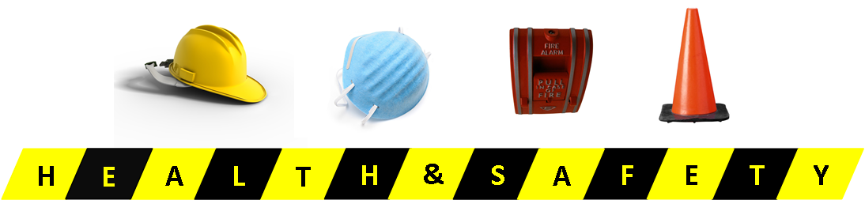
Guelph Family Health Team Monthly Facility Walkabout

Conducted by: ________________________________
Date: ________________________________

General Conditions
Circle any of the following words that require attention.
- Are all walking surfaces, including aisles clean, clear of debris, dry, and accessible?
- Any trip hazards, including cords, boxes, torn carpet, other?
- Are workstations, offices, meeting rooms, washrooms, reception or wait areas, storage and empty space in good condition?
- Is area lighting adequate and safe?
- Is general housekeeping free from bacteria, odour, dust, etc.?
- Are storage areas neat and orderly with no potential for falling boxes or spills, etc.?
- Are WHMIS standards being enforced, such as hazardous materials storage, protective use, etc.?
- Is office furniture and equipment in safe and ergonomically correct condition?
Building Evacuation and Safety
- Are there sufficient exits properly signed and lighted?
- Are all exit paths accessible for all persons?
- Are all exit doors operable at all times?
- Is emergency lighting operable?
- Does the fire alarm work?
- Has the fire alarm been tested?
- Are emergency phone numbers posted in visible areas throughout the building?
- Has a fire drill or evacuation test been conducted this year?
Fire Prevention
- Are portable fire extinguishers available?
- Is the sprinkler smoke, heat, security systems operable and tested regularly?
- Is a no smoking policy enforced?
- Is there any evidence of electrical equipment or plugs overheating?
- Are multiple plug outlets and use of extension cords kept to a minimum?
- Are portable heating devices UL-listed? (next page)
Kitchen
- Is the cooking ventilation system equipped with filters?
- Is a small kitchen fire extinguisher visible?
- Is a first aid kit contained in the kitchen?
- Are there any visible safety risks in the kitchen area, including knives, wires, outlets near sinks, wet floors, etc.?
Equipment
- Are state inspection certificates on file and current?
- Is the photocopier operating safely and in an area where emissions are not a health hazard?
- Any office equipment that requires repair or maintenance?
Other Site Specific Concerns
List: ______________________________________________________________________________________________________________________________________________________________________________________________________________________________________________________________________________________________________________________________________________________________________________________________________________________________________________________________________________________________________________________________________________________________________________________

