Association of Family Health Teams of Ontario

2 0 2 2
ONTARIO ELECTION
A D V O C A C Y T O O L K I T
AFHT O │ 2022 Ontario Election 1

BACKGROUND
The next provincial election in Ontario is set for June 2, 2022. We want to ensure all parties and candidates know the Association of Family Health Teams of Ontario (AFHTO) and their policy priorities.

This campaign is critically important to ensure parties and candidates understand what team- based primary care is and the value it provides Ontarians and the health system overall. The ultimate goal is to see party platform commitments for team-based primary care in the run up to the 2022 election, signalling they will be funded and expanded across the province.

As an organization, AFHTO:



Advocates for team-based primary care and why it needs to be a priority.

WE HEARD YOU.
Has access to providers to report their perspectives.
Partners with government to ensure team-based primary care is the foundation of the healthcare system.

Highlights of a recent survey of AFHTO members include:

- Over 98% of respondents agreed it is important that AFHTO engages on behalf of members during the upcoming election to influence healthcare policy.

- Almost 90% of respondents think it is important that AFHTO members engage with their local MPPs and candidates.

- Increasing access to interprofessional team-based primary care for all Ontarians is the top policy priority for members.

- AFHTO members are ready to engage using various mediums, but meeting with candidates and providing expert media commentary on health issues were the top priorities.

- AFHTO members overwhelmingly want to receive advocacy toolkits and training to support their engagement in the 2022 election.

HOW CAN YOU
PARTICIPATE?

Set up meetings with your local Member of Provincial Parliament (MPP) candidates and use key messages – don’t forget to leave behind the one-pager!
1

Post the one-pager in your office to educate your team members and the public.
2

Share social graphics on social media.
3

Hand out voter cards to your patients and the broader community and encourage them to ask their local MPP candidates about their commitment to team-based primary care.
4

Encourage your colleagues and peers to get involved and take action – it takes a team!
5

KEY MESSAGES

- Access to healthcare is about more than a check-up with a doctor or a hospital visit for emerging issues — it’s about proactive care for a person’s mental and physical wellbeing.

- When it comes to publicly funded primary care that is timely, accessible, and comprehensive, it takes a team.

- Yet, only one in four Ontarians have access to team-based primary care, which is proven to offer more timely access to care, better coordination of care for patients, and cost savings for our health system.

- Team-based primary care is family doctors, nurse practitioners, nurses, social workers, pharmacists, dietitians, and others, all working together to support a patient and their needs.

- With the support of team-based primary care, Ontarians have one door to their health needs and access to a team of providers who know them, their family, their caregivers, and their history.

- Seniors managing multiple conditions and medicines, people suffering from mental health challenges, and parents caring for children with chronic conditions need an integrated primary care team that works hand-in-hand to provide coordinated care.

- Every Ontarian deserves access to comprehensive and equitable care where and when they need it – no matter who they are, whether they live in northern or rural areas, or how much money they make – but for most Ontarians, this is out of reach.

- It’s time for Ontario to commit to access to team-based care for every person who needs it. This can be achieved with a commitment to invest $75 million per year for the next 10 years in team-based care.

- An investment in team-based care is an investment in supporting better seniors’ care, improving access to mental health care, and improving health outcomes.

- When it comes to building a better health system for Ontarians, it takes a team.

SECONDARY MESSAGES

WHAT IS TEAM-BASED PRIMARY CARE?
- Team-based care is proactively caring for a person’s mental and physical wellbeing. And that’s precisely what we do.

- Publicly funded team-based primary care is family doctors, nurse practitioners, nurses, social workers, pharmacists, dietitians, and other professionals, all working together to support a patient and their daily needs.

- Team-based primary care provides comprehensive, coordinated, and cost-effective care, while improving patient outcomes and satisfaction.

- When it comes to keeping Ontarians healthy, it takes a team.

WHY DO WE NEED TEAM-BASED PRIMARY CARE?
- Our healthcare system is complex, each patient’s needs are unique, and a team approach is needed to meet these needs.

- Without access to team-based primary care when it’s needed, too many people fall through the cracks, negatively impacting their health and increasing costs to our healthcare system to provide care that could have been prevented.

- Evidence shows it can cost the province three times more to care for a patient who is unable to access high-quality team-based care.

- Yet, only one in four Ontarians benefit from having local access to an interprofessional care team.

- Primary care teams are there for populations that need support the most – regardless of where they live – such as seniors, those dealing with mental health challenges, and others with chronic illnesses.
- When it comes to better access to care, it takes a team.

HOW CAN TEAM-BASED PRIMARY CARE HELP PATIENTS & OUR HEALTH SYSTEM?
- Connecting Ontarians who need team-based primary care in their local community will provide higher-quality care, while strengthening existing teams.

- Team-based primary care is proven to offer more timely access to comprehensive, public healthcare, better coordination of care for patients, and cost savings for our health system.

- Expanding publicly funded team-based primary care as we advance our system will help remove the silos many patients currently face, leading to better data-sharing, caregiver support, and improved integrated treatment.

- Investing $75 million per year for 10 years could ensure that every Ontarian who needs it has access to team-based care, meeting our goal to ensure no patient is left behind.
- When it comes to building a stronger health system, it takes a team.

TOOLKIT
In this tookit, you will find the following advocacy materials:

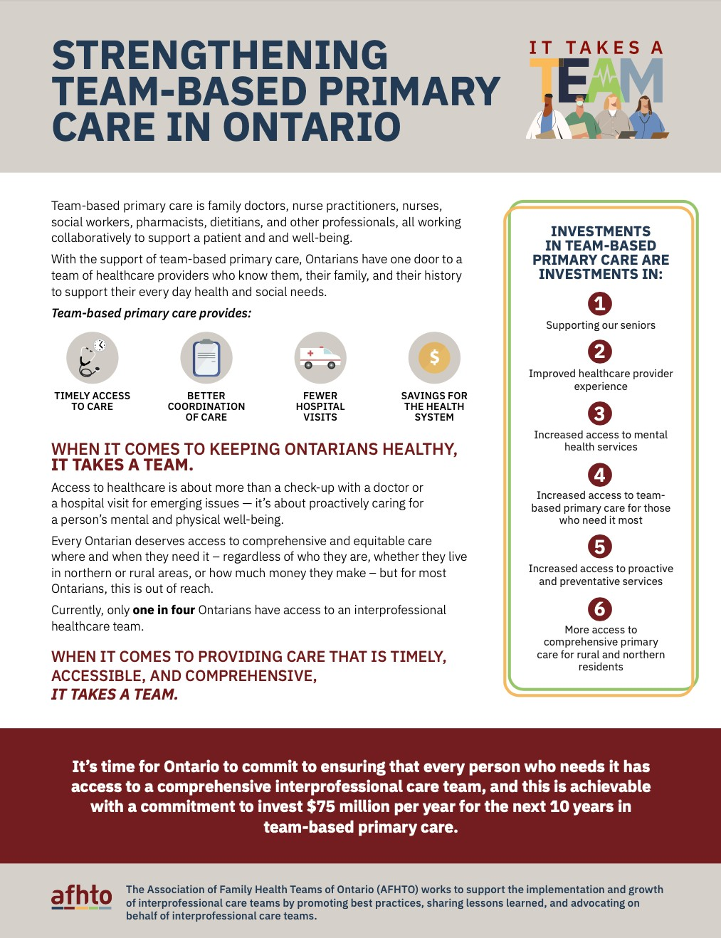
ONE-PAGER
This one-page document provides a summary of the importance of team-based primary care in Ontario. We suggest using this document
in your meetings with MPP candidates and other political actors. Make sure you update it with the contact information of your team, and you can also edit the six priorities section to investments most important to your local team.

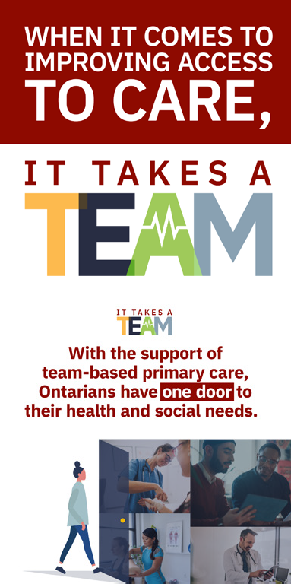
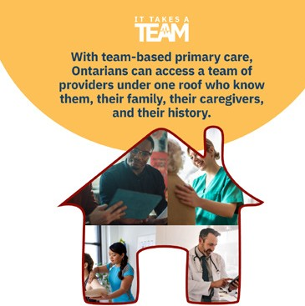
SOCIAL MEDIA POSTS
Post these graphics and use the provided copy for the post to get the word out and increase support for team- based primary care.
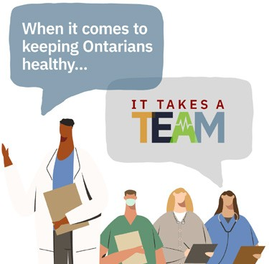

VOTER CARD
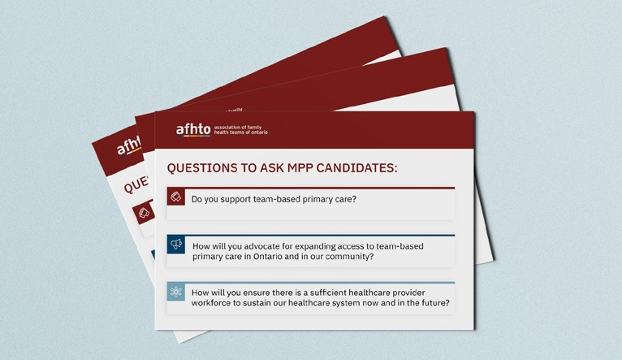
Print these cards and hand them out to your patients and the community. When a MPP candidate comes to their door, they will be ready to ask what they will do for team-based primary care.

FAQs

- When should I reach out to MPP candidates for my region?

As soon as candidates are confirmed, they are usually available for stakeholder meetings. The earlier you can engage with a candidate, the more likely the issues you are advocating for will be included for consideration in the party platform.

- How do I find my local MPP candidates and request a meeting?

Most local candidates will start promoting right away and you should start seeing their promotional materials online and in your region. A quick search should bring you to their campaign website where you can find their contact information. You can also find listings of party candidates on party websites:

Ontario Liberal Party Candidates
Ontario Conservative Party Candidates
Ontario New Democratic Party Candidates
Ontario Green Party Candidates

To request a meeting, an email like the one below can be sent to the candidate:

Dear [candidate’s name],

Thank you for your interest in representing the riding of [riding name] as our Member of Provincial Parliament. I’m a proud constituent and [insert your role ex. physician, nurse practitioner, executive director] at [team name] in [town/city name].

Our team would appreciate the opportunity to meet with you about the value of team-based primary care and how further support for this model is needed to strengthen our healthcare system. Team-based care is timely, accessible, cost effective, and comprehensive; however, only one in four Ontarians have access to it.

It is important to make it accessible for anyone who needs it. It provides wraparound care for patients, which is especially important for those with multiple conditions or who may be more vulnerable, and leads to fewer hospital visits.

To provide the care that many people in [riding name] need, it takes a team. We would like the opportunity to tell you about the work we do and why it is important for the people you are seeking [re]election to represent.

Thank you for considering this request, and we look forward to hearing from you.

Sincerely,
[name and contact info]
- My local candidates are not willing to meet with me – what do I do?

Sometimes candidates have too many requests for meetings or prioritize public appearances and door knocking. Although an in-person/virtual meeting is preferred, if you are unable to meet with the candidate, send them another email with the key messages and attach the one-pager we have provided. Another option is to write a letter with the key messages and take it and the one-pager to the campaign headquarters. A member of the team will likely meet with you and accept the materials.

If your candidate is not willing to meet with you, send the email below to the email address provided on your candidate’s website:

Dear [insert candidate’s name],

Thank you for considering our request to meet. As you’re unavailable, we’d like to provide additional information on the importance of investing in team-based primary care.

Attached is a document on why we need more team-based primary care in Ontario as well as the 2022 Pre-budget Submission from the Primary Care Collaborative, outlining what is needed to help build a province where people can access better care, more integrated more, and more accessible and continuous care.

You can reach us at [contact information]. Our team would welcome the opportunity to meet with you to answer your questions. Please reach out when time allows to discuss how we can strengthen our healthcare system and deliver the best care for people in [riding name], together.

Sincerely,
[name and contact info]

- I have met with my local MPP candidates and used the key messages, now what?

After you meet with the local candidate, email them thanking them for their time and reiterate the key messages and takeaways from your meeting. Attach the one-pager to the email as well.

After meeting with your candidate, send the email below to the email address provided on your local candidate’s website.

Dear [insert candidate’s name],

On behalf of [team name], thank you for meeting with us to discuss the importance of team-based primary care – for the benefit of the people in [riding name] who need it the most and for the province as a whole.

As mentioned in our meeting, team-based care is timely, accessible, cost effective, and comprehensive; however, only one in four Ontarians have access to it. By providing this care to every Ontarian who needs it, we can have better coordination of care, cost savings to our system, and better overall health outcomes. An investment of $75 million per year for 10 years means better seniors’ care, more access to mental health services, and more doctors in rural and northern communities.

Thank you once again. Please reach out any time if you have any further questions.

Sincerely, [name and contact info]

Email advocacy@afhto.ca to let AFHTO know you have completed the engagement! Please also share pictures and tag @afhto on Twitter

- What is AFHTO leadership doing?

AFHTO is evaluating what tactics can best be used to leverage our member and stakeholder support, how best to get our message out during the campaign period, assessing the right tone for the campaign, and meeting with government, MPPs, and political parties. AFHTO is here to support members’ advocacy however needed.

- Who is most appropriate from my team to attend these meetings?

It is up to you and your team. We recommend sending representatives who are most comfortable advocating. We suggest considering your executive director, a physician, an IHP, a board member, and/or a patient who can speak to the importance of team-based care.

- What do we consider a successful campaign?

The election in June is important for the healthcare system. Our campaign will be deemed a success if there is more public awareness of team-based primary care. We hope to see mention of team-based primary care across party platforms, including both funding to support existing teams and the expansion of teams.

- Why are we not focusing more on health human resources (HHR) challenge and a request for increased salaries in our key messages?

While we recognize that HHR and salaries for our team members is critical to address, the focus of this campaign is on the patient and the benefits of team-based primary care to Ontarians and the healthcare system. This will be the most effective and compelling line of messaging for candidates to achieve success.

Given the HHR challenge throughout the health system, AFHTO is working with partners and stakeholders to advocate for the need to address capacity, burnout, and wage/benefits parity across the system. We encourage you to voice your concerns and the need for solutions to further support patients.

We encourage you reference AFHTO’s recommendations in the 2022 Pre-budget Submission and leave a copy of the submission behind at meetings.

- How did AFHTO arrive at the $75 million per year for 10 years request for government?

AFHTO came to this figure after multiple conversations with ministry officials on current coverage of team-based care for those who need it and what it would likely cost to close that gap over 10 years based on current spending and population trends.

As a reference point, the current Ontario human resources budget for family health teams is $350 million annually (excluding physician funding), and it serves approximately 3.5 million Ontarians (or 25% of Ontarians). Our goal is to ensure that every Ontarian who needs or wants team-based primary care has access to it. To reach this threshold, we would need to invest an additional $75 million per year in human resources in primary care teams over the next 10 years.

It is also important to have a reasonable long-term ask of the next provincial government. Although overhead and other expenses are critical components to successful team-based primary care, we are focusing our ask on increased investment in HHR. We believe this is a reasonable and appropriate ask at this time.

- How does the language around the need for a primary care team approach fit into the broader language around Ontario Health Teams (OHT)?

One of the key reasons we are using the selected language of “team-based primary care” is because specific types of healthcare teams have become politicized.

In addition, the current government’s plans OHTs are unclear. Even if family health teams and other primary care team-based models share similar attributes with OHTs (ex., collaboration, connectivity), our messages and content focus on team-based primary care.

Like the topic of HHR, you may have the opportunity to explain how primary care teams can work within an OHT model or other team-based models in the system during your advocacy meetings. However, this campaign is not focused on the type of model, but on supporting and investing in team-based primary care.

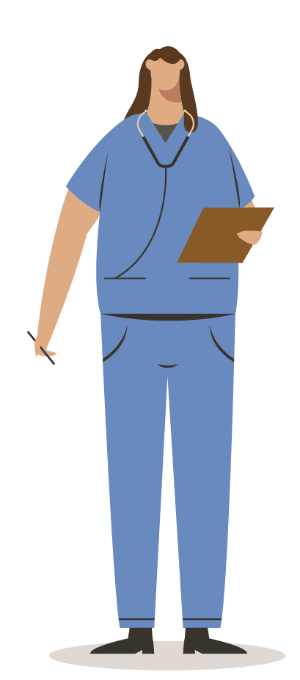Questions?
Beth MacKinnon
advocacy@afhto.ca

400 University Ave, Suite 2100
Toronto, ON M5G 1S5

Association of Family Health Teams of Ontario
AFHT O │ 2022 Ontario Election 13

