Children’s Mental Health Ontario
Back-to-School Mental Health Kit

While back-to-school is hard for most children and youth in a normal year, this year our kids are facing extraordinary circumstances relating to the pandemic and infection control measures.

Through recent research and a survey of parents in Ontario, we know parents are experiencing unprecedented stress and are worried about their kids’ mental wellness. Understanding that parents’ stress can also contribute to children’s stress, it is critical that we support parents as families prepare for the transition back to school.

To help, Children’s Mental Health Ontario has prepared a Back-to-School Mental Health Kit with resources and tips. The kit includes articles like how to support your child’s mental wellness while encouraging pandemic prevention measures, as well as tips directly for parents to help manage their own stress and support their kids. See below for some draft newsletter copy, as well as social posts and graphics to help us spread the word about these resources.

As well, be sure to check out our new report with the Ontario Centre of Excellence in Child and Youth Mental Health, which articulates the impact of the pandemic and back to school on child and youth mental health.

In addition, we have created resources that you can use on social media and directly with patients and families. Click here to browse the graphics and resources, including have PDFs with tips for download in both French and English.

Back to school social media post ideas
The below posts point to our website, where the resources are primarily in English for now. We also have graphics with tips in French here that can be used directly on your social media channels.

#1 – Back to School Mental Health Kit

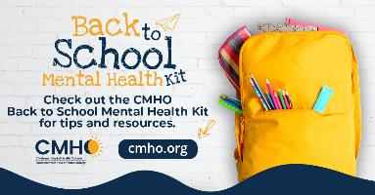
Full size graphics: Twitter, Facebook, Instagram (more English graphics here)

The pandemic is affecting children’s mental health. The start of the school year is creating new challenges and concerns. Check out Children’s Mental Health Ontario’s Back to School Mental Health Kit for tips and resources. https://cmho.org/back-to-school/ #kidscantwait

To help children and parents prepare for the start of the school year and promote mental wellness, Children’s Mental Health Ontario has released a Back to School Mental Health Kit. https://cmho.org/back-to-school/ #kidscantwait

#2 Find Help

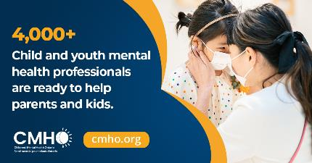
Full size graphics: Twitter, Facebook, Instagram (more English graphics here)

We know back to school is causing stress for families. You don’t have to do this alone. Child and youth mental health centres across the province can help. No referral required, and no problem is too big or too small. https://cmho.org/findhelp/ #kidscantwait

You don’t have to do this alone. Child and youth mental health centres across the province can help. Walk in clinics, virtual and in person services are available – free, and no referral required. https://cmho.org/findhelp/ #kidscantwait

Draft Newsletter Copy

In addition to navigating your roles as front-line care providers in the pandemic, we know many of you are also parents and caregivers preparing for the return to school. We wanted to share a Back to School Mental Health Kit from our partners at Children’s Mental Health Ontario (CMHO). The online kit has helpful information and practical tips to help you navigate this, including:
- Six Tips to Support Your Child’s Mental Wellness and Prepare for the Start of the School Year
- Supporting Children’s Mental Wellness While Encouraging Pandemic Prevention Measures
- Back-to-School Tips for Parents

In addition, CMHO has prepared PDFs with tips that you can use directly with patients and families. Note the PDFs are AODA complaint. See the links below to download the PDFs:
- Six Tips to Support Your Child’s Mental Wellness and Prepare for the Start of the School Year (French here)
- Supporting Children’s Mental Wellness While Encouraging Pandemic Prevention Measures (French here)

If you are worried about your child’s mental wellness, CMHO’s network of child and youth mental health centres are here for you. Even a single session through a virtual or in person walk-in clinic can help. Find your closest centre at www.cmho.org/findhelp.

If you have questions about the resources, please get in touch with Jessica Behnke, Director Strategic Relations and Communications at jbehnke@cmho.org

