Cancer Screening Toolkit Introduction

What is the Cancer Screening Toolkit?
Further to the memorandum issued by the Ministry of Health and Long Term Care (MOHLTC) in January 2013, introducing Quality Improvement Plans (QIP) to the primary care sector, Cancer Care Ontario (CCO) has developed a Cancer Screening toolkit for those Family Health Teams (FHT) that decide to include Cancer Screening as part of their QIP.

“The QIP is about improving patient/client and provider experience, care effectiveness and value, through system improvement, continuously over time.”¹ All Family Health Teams (FHTs) in Ontario are required to develop and submit a QIP to Health Quality Ontario (HQO) by April 1, 2013 outlining their quality improvement efforts for the upcoming fiscal year. There are three mandatory priority QIP areas: access, integration and a patient-centred approach. In addition to these areas, FHTs may choose to include cancer screening as part of their QIP plans.

Why include cancer screening in the QIP?
Including cancer screening in the QIP supports primary care’s focus on quality patient care. Regular screening can find cancer when it is small, which means there is a better chance of treating the cancer successfully, it is less likely to spread and there may be more treatment options.² This toolkit will assist FHTs in planning, implementing, monitoring and reporting on improvements in colorectal, cervical and breast cancer screening. It contains Instructions (Section 1), a Planning Tool (Section 2), a Measurement Tool (Section 3) and a Cancer Screening Sample Timeline (Section 4). If you choose to use the toolkit, please let us know by emailing PrimaryCare@cancercare.on.ca with “QIP” in the subject line. Informing us of your decision to participate will allow us to provide with any support you might require.

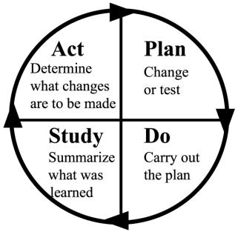

CCO recommends applying the Plan, Do, Study, Act (PDSA)³ cycle of continuous improvement for QIP development.

 | What happens in this part of the cycle?⁴ | Tips
Plan | - Create a baseline: know current screening rates  - Define an achievable screening rate goal  - Define data required to track and measure your goal | - Keep things simple and manageable, and set small and achievable goals (e.g., focus on only one type of screening for the first year)
Do | - Put the plan into practice  - Collect data  - Record useful observations | - Ensure that data is collected and recorded consistently
Study | - Analyze the data collected to track progress  - Determine the next step needed to help meet the screening rate goal | - Set a timeline for progress checkpoints that are achievable and make sense for your practice
Act | - Make changes | - Make simple changes to help achieve goals (e.g., take opportunities to discuss screening with patients in the office for other reasons)
¹ 2013/14 Quality Improvement Plan Guidance for primary care organizations in Ontario. Available from: http://www.health.gov.on.ca/en/pro/programs/ecfa/legislation/qi_primary.aspx.
² CCO Internet, Prevention & Care, Screening, Breast Cancer Screening. Available from: http://www.cancercare.on.ca/pcs/screening/breastscreening.
³ Langley et al. 1996. Link available upon request.
⁴ National Academy for State Health Policy. PDSA Cycles. Available from: http://www.nashp.org/sites/default/files/abcd/abcd.ut.pdsa.cycles.definedsimple.pdf .
¹ 2013/14 Quality Improvement Plan Guidance for primary care organizations in Ontario. Available from: http://www.health.gov.on.ca/en/pro/programs/ecfa/legislation/qi_primary.aspx.
² CCO Internet, Prevention & Care, Screening, Breast Cancer Screening. Available from: http://www.cancercare.on.ca/pcs/screening/breastscreening.
³ Langley et al. 1996. Link available upon request.
⁴ National Academy for State Health Policy. PDSA Cycles. Available from: http://www.nashp.org/sites/default/files/abcd/abcd.ut.pdsa.cycles.definedsimple.pdf .

Section 1: Instructions

1.1 Plan
Your FHT should begin by creating a cancer screening rate improvement plan. There are five simple steps involved in this process.
Five-Step Plan Checklist:
- 1. Identify team members
- 2. Fill out the Planning Tool (Section 2)
- 3. Fill out Part A of the Measurement Tool (Section 3)
- 4. Orient primary care providers, healthcare professionals and other staff who will be involved in the initiative
- 5. Make staff and patients aware of initiative
1. Identify team members
Identifying who will be involved and ensuring that they are properly oriented is a key to successful implementation. The FHT will need to:
- Select a lead coordinator to act as main point of contact
- Ensure that there is enough staff support to carry out the initiative
- Identify who will be administering cancer screening (e.g., primary care providers, nurses, other healthcare professionals)

2. Fill out the Planning Tool
The Planning Tool (Section 2) provided by Cancer Care Ontario is a step-by-step planning guide. It will help your FHT identify its goals, measurement plan, and approach for change implementation for the initiative.
3. Fill out the Measurement Tool
There are a number of data sources that can be used to establish the baseline, including your Electronic Medical Record (EMR), the Target Population/Service Report (TPSR) and the ColonCancerCheck Screening Activity Report (CCC SAR) for colorectal cancer. Primary care providers wishing to register for access to their CCC SAR can do so by contacting eHealth Ontario at ONEIDBusinessSupport@ehealthontario.on.ca. Registration appointments will be scheduled based on location and/or the date of your request. Record the baseline and measurement plan for the initiative in the Measurement Tool (Section 3). Reviewing it regularly will help your FHT stay on track to achieve its target.
NOTE: It is important to be consistent when developing measures and tracking progress. All primary care providers, healthcare professionals and staff involved should be trained to follow a consistent methodology. Your FHT can decide what data source is used; the following are some examples:
- Searchable fields in your Electronic Medical Record (EMR) (e.g., creating a query based on screening type, gender, age)
- Use the Target Population/Service Report (TPSR) issued by the Ministry of Health and Long Term Care (MOHLTC) twice a year in April and September
- OHIP tracking codes
- PAP – Q011
- Mammogram – Q131
- FOBT – Q133

4. Orient staff directly involved
Once you have filled out the Planning Tool (Section 2), it is important to hold an orientation session for primary care providers, healthcare professionals and other staff members directly involved in the initiative. Provide participants with this toolkit and build/formalize changes to current practice workflows to accommodate the new initiative.
5. Educate staff and patients indirectly involved
Hold staff meetings, send emails and post notices on staff bulletin boards to educate primary care providers, healthcare professionals and other staff who are indirectly involved in the initiative so that the QIP process runs smoothly.
Develop posters and stock the waiting room with cancer screening brochures to educate patients about the QIP. Communicating this type of initiative to patients will show them that their FHT is proactive in delivering quality preventative care and will make them aware that they may be contacted as part of the initiative. Please refer to the Appendix for helpful resources.

1.2 Do
There are two steps in the Do phase of the cancer screening QIP.
Two-Step Do Checklist:
- 1. Develop a list of patients to be screened
- 2. Execute!

1. Develop patient list
To support your activities, your FHT will need to generate a list of patients who are due/overdue for screening (potential sources of information include EMRs and the ColonCancerCheck [CCC] Screening Activity Report).
Below find one example of how to track clients eligible for screening:
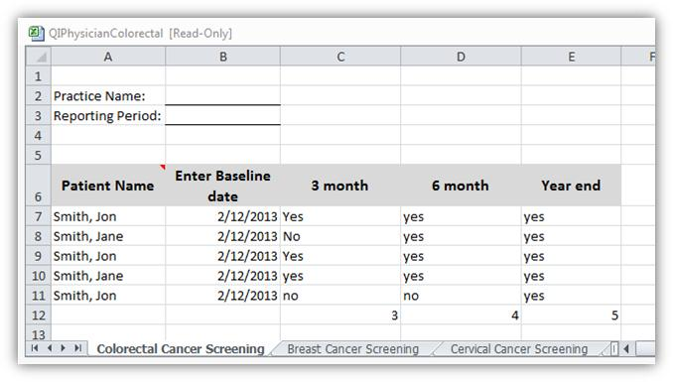
2. Execute plan
Execute your planned activities. Throughout the process, your lead coordinator should supervise the initiative and provide timely responses to staff questions. Holding regular team meetings to track progress, troubleshoot challenges and celebrate successes are key to ensuring that the team stays engaged and motivated and that issues are addressed.

1.3 Study
There are three steps in the Study phase of the cancer screening QIP.
Three-Step Study Checklist:
- 1. Fill out Part B of the Measurement Tool(Section 3)
- 2. Review results with team
- 3. Share results with all primary care providers, healthcare professionals and other staff members
1. Fill out Part B of the Measurement Tool
Fill out Part B of the Measurement Tool (Section 3) periodically (e.g., every three months) to track your team’s progress.
2. Review results
Hold regular checkpoint meetings (e.g., every three months), where the Measurement Tool (Section_3) can be used to review outcome and process measures, and review progress made since the start of the initiative.
3. Share results
Results can be shared within the FHT and patients to keep them informed of the initiative’s progress.

1.4 Act
Modify the plan, as appropriate, based on feedback from the Study phase. Make any necessary adjustments to the process and ensure that all involved primary care providers, healthcare professionals and other staff members are kept abreast of these changes.
At the end of the fiscal year, evaluate the quality improvement initiative.
- Take your final measures and complete Part C of the Measurement Tool (Section 3) to determine whether your FHT achieved its target screening rates.

- Get feedback from primary care providers, healthcare professionals, other staff and patients who were involved in the initiative regarding:
  - What went well
  - What challenges/difficulties were encountered
  - What could be done differently
Staff can evaluate the initiative through online or paper surveys. Selected patients can complete the evaluation through a patient satisfaction survey (which could be included in a patient package) or through documented verbal discussions.

Section 2: Planning Tool
This Planning Tool is intended to support the development of your practice’s Cancer Screening Quality Improvement Plan (QIP) and is to be used in conjunction with the accompanying Instructions document.
As you fill out this step-by-step tool, please refer to the sample completed Cancer Screening QIP below.
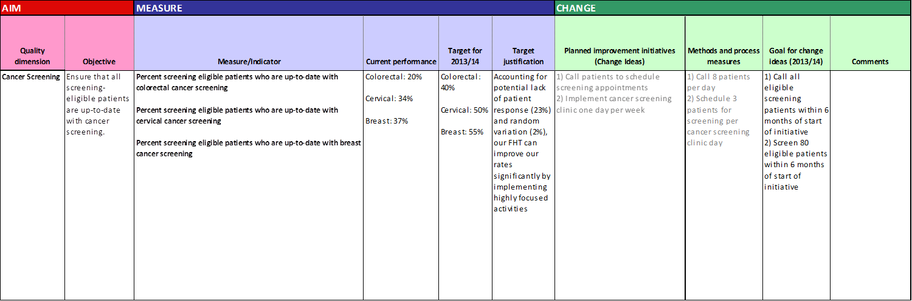
6
4
5
2
3
1
Step
AIM | - Identify the objective and measure  /indicator | This will form the basis of all of your activities. The indicator selected should be detailed and the methodology of measurement should be clearly identified. | State the objective of this initiative (e.g., ensure that all screening-eligible patients have been screened):
 |  |  | List measure(s)/indicator(s) (e.g., percent of screening eligible patients who are up-to-date with cervical cancer screening):
 |  |  | Identify methodology (e.g., numerator: number of eligible patients who are up-to-date with screening / number of screening eligible patients according to screening guidelines):
MEASURE | - Establish a baseline for performance | Using the measure or indicator outlined in Part 1, identify the FHT’s baseline. Record the baseline in both the QIP and the Measurement Tool. There are a number of data sources that can be used to establish the baseline:  - Electronic Medical Record (EMR): use the reporting/query functionality in your EMR  - Target Population/Service Report (TPSR): You may establish your baseline screening rates based on previous year TPSR  - Cancer Care Ontario’s ColonCancerCheck Screening Activity Report (CCC SAR): if all primary care providers in the FHT are compensated under the Patient Enrolment Model (PEM), and all receive their CCC SAR, data in the CCC SARs can be consolidated manually to establish a baseline screening rate for the colon cancer within the FHT  NOTE: It is important to be consistent when developing measures and tracking progress. All impacted primary care providers, healthcare professionals and staff should be trained on following a consistent methodology. Your methodology has to be consistent but not perfect. | Identify baseline (for each indicator identified):
 |  |  | Describe the method for baseline calculation (for each indicator identified) and data sources used:
 | - Identify what your target for year will be | There are a number of ways to determine your target for the year. You may choose to use the Ontario average as your FHT’s target. LHIN and provincial screening rates can be found in the Cancer Screening Quality Index (CSQI) report and can assist in setting targets. Your targets should be achievable with a bit of a stretch component, but not unattainably high. | Identify the target for each of the indicators selected:
 |  |  | Describe target justification, including assumptions and adjustments:
CHANGE | - Decide on what changes the FHT will make to current workflows in order to achieve the goal | Depending on your practice structure and supports available, some activities that could be implemented include:  - Developing patient packages that include completed requisitions, an FOBT kit and any other information. Patients can pick up their packages when they are in the area or before/after an appointment. Package contents could include:  - CCC  - FOBT kit  - Instructions (tear-away sheet—CCO has a sample)  - OBSP:  - Mammography requisition  - Lab locations sheet  - Instruction sheet  - OCSP (Pap): book appointments or conduct screening on an opportunistic basis (i.e., when a patient attends an appointment for another reason)  - Assign primary care providers and/or other healthcare professionals to hold screening clinics for a period of time  - Automate reminders for cancer screening in the FHT’s EMR | List the activities that your FHT will be implementing:
 | - Identify how changes will be implemented and identify process measures | This section identifies the activities and process measures that the FHT will be implementing and the targets for each measure. | List process measure(s) for the activities identified in Part 4:
 | - Goal for change ideas | Identify the goals that the FHT is aiming to achieve based on the process measures. These should tie back to the overall objectives of the initiative. | Identify goal(s):

Section 3: Measurement Tool

Part A: Performance Measurement Planning
Identify the indicators and process measures for your initiative and fill out tool below. For each indicator, identify the baseline/current value. Below find some examples of possible indicators, methodologies and baselines.
1. Indicator Selection
-What is/are the indicator(s)/outcome measure(s) of this initiative?
-How is/are the indicator(s)/outcome measure(s) going to be calculated?
-What is the baseline?
Indicator(s) | Methodology | Baseline Value | Target Values
e.g., Percentage of screening-eligible patients who are up-to-date with colorectal cancer screening | Numerator: (e.g., number of patients who have been screened for colorectal cancer)  Denominator: (e.g., total number of patients who fall within colorectal screening guidelines) | e.g., 200 screened patients/1,000 total patients who fall within guidelines = 20% | (as stated in QIP)
e.g., Percentage of screening-eligible patients who are up-to-date with cervical cancer screening | Numerator: (e.g., number of patients who have been screened for cervical cancer)  Denominator: (e.g., total number of patients who fall within colorectal screening guidelines) | e.g., 34 screened patients/100 total patients who fall within guidelines = 34% | (as stated in QIP)
e.g., Percentage of screening-eligible patients who are up-to-date with breast cancer screening | Numerator: (e.g., number of patients who have been screened for breast cancer)  Denominator: (e.g., total number of patients who fall within breast screening guidelines) | e.g., 370 screened patients/1,000 total patients who fall within guidelines = 37% | (as stated in QIP)

2. Process Measure Selection
Process Measure(s) | Methodology
e.g., Patient response rate | e.g., Number of patients who come for screening out of those called

3. Period Duration
-How often will the checkpoints occur (e.g., every quarter/month/week)?

Part B: Periodic Checkpoint Review (to be filled out routinely)
Period: (e.g., May 1st–June 1st)
1. Indicator Evaluation
Indicator(s) | Period-End Result | Change from Baseline | Change from Last Period
e.g., Percentage of screening-eligible patients who are up-to-date with colorectal cancer screening | Numerator: Patients who have been screened (add those who are part of the baseline of screened patients and those who have been screened between day of baseline measurement and checkpoint review)  Denominator: Total pool of patients eligible for screening, e.g., 23% | e.g., 23% - 20 = +3% | e.g., N/A
e.g., Percentage of screening-eligible patients who are up-to-date with cervical cancer screening | e.g., 36% | e.g., +2% | e.g., N/A
e.g., Percentage of screening-eligible patients who are up-to-date with breast cancer screening | e.g., 39% | e.g., +2% | e.g., N/A

2. Process Measure Evaluation
Process Measure(s) | Current Value | Change from Last Period | Interpretation  (this section will inform the Period Analysis)
e.g., Percentage of screening-eligible patients who are up-to-date with colorectal cancer screening | e.g., Only 25% of patients who have been directly contacted have come in for screening | e.g., N/A | e.g., Patients may not be fully aware of importance of screening.

3. Period Analysis
-Overall, how is the FHT performing?
-What issues have arisen? What is the issue mitigation plan?

Part C: Final Evaluation
To be conducted in preparation for submission of final QIP report and to plan for next period.
1. Indicator Evaluation
Indicator(s) | Period-End Result | Change from Baseline | Change from Last Period
e.g., Percentage of screening-eligible patients who are up-to-date with colorectal cancer screening | (Use methodology outlined above to calculate this) | (Calculate current period percentage and subtract baseline value) | (Calculate current period percentage and subtract from previous period percentage)
e.g., Percentage of screening-eligible patients who are up-to-date with cervical cancer screening
e.g., Percentage of screening-eligible patients who are up-to-date with breast cancer screening

2. Process Measure Evaluation
Process Measure(s) | Current Value | Change from Last Period | Interpretation  (this section will inform the Period Analysis)
e.g., Percentage of screening-eligible patients who are up-to-date with colorectal cancer screening | Use same methodology as previous periods | e.g., 10% | (Interpret results)

3. Final Period Analysis
-How did the FHT perform over the final period?

4. Final Review of Initiative
-How did the FHT perform over the entire initiative?
-Were targets achieved?
-What successes were achieved?
-What issues arose? How were they mitigated/addressed? How successful were the plans to address the issues?

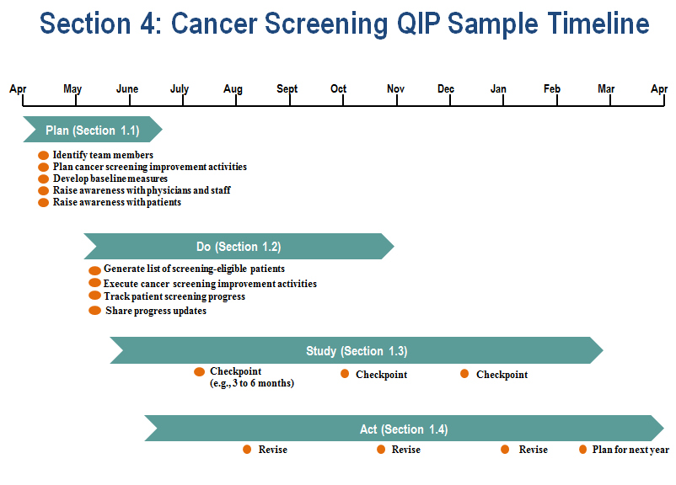

Appendix

Support Resources
Table 1: for providers
Screening program | Resource | How it can help | Where to find it
Ontario Breast Screening Program (OBSP) | - Requisition for high risk screening  - Summary of evidence  - Provider education brochure | - Defines the criteria for a high-risk female and evidence supporting screening recommendations.  - Provides information about the OBSP screening program and how it can assist primary care providers. | Download from:  www.cancercare.on.ca/pcs/screening/breastscreening/resources/
Ontario Cervical Screening Program (OCSP) | - 2012 Ontario Cervical Screening Cytology Guidelines Summary  - Information for Healthcare Providers on the Ontario Cervical Screening Program (OCSP) | - Summary of Ontario screening guidelines, including recommendations for follow-up of abnormal cytology.  - Provides information about the OCSP screening program and a description of the evidence that led to recent changes to the screening recommendations. | Download from:  http://www.cancercare.on.ca/pcs/screening/cervscreening/hcpresources
ColonCancerCheck (CCC) | - ColonCancerCheck Screening Activity Reports (SAR) | - The SAR provides a summary of your colon cancer screening status of enrolled patients, including a list that identifies patients who require follow-up. | http://www.cancercare.on.ca/cms/one.aspx?portalId=1377&pageId=87564
 | - Screening Evidence Summary  - Clinical Reference Card | - Defines those who are at an increased risk of colorectal cancer vs. the asymptomatic average risk population and provides a snapshot of the screening recommendations.  - Helps you assess an individual’s risk for developing colorectal cancer. | Download from:  http://www.health.gov.on.ca/en/pro/programs/coloncancercheck/resources.aspx

Table 2: for patients
Screening program | Resource | How it can help | Where to find it
Ontario Breast Screening Program (OBSP) | - Breast Cancer Screening: It’s never this obvious | - Brochure | Download or order hard copies from Service Ontario:  Visit www.publications.serviceontario.ca (search “breast cancer screening”)
 | - Breast Cancer Screening Decision Aid (Public Health Agency of Canada) | - Handout; provides resources to assist in decision-making related to participating in breast screening. | Download from:  http://www.phac-aspc.gc.ca/cd-mc/mammography-mammographie-eng.php
 | - Breast Cancer and Your Risk (Public Health Agency of Canada) | - Brochure; describes biological risk factors, lifestyle risk factors and common misconceptions related to the development of breast cancer. | Download from:  http://www.phac-aspc.gc.ca/cd-mc/pdf/Breast_Cancer_Risk-eng.pdf
Ontario Cervical Screening Program (OCSP) | - Cervical cancer screening: Find out when it is the right time for you to start screening | - Handout | Download from:  http://www.cancercare.on.ca/pcs/screening/cervscreening/hcpresources  Order hard copies from Service Ontario:  Visit www.publications.serviceontario.ca (search “cervical cancer screening”)
 | - Cervical cancer screening: What your abnormal Pap test means | - Handout; describes the potential causes of an abnormal result, emphasizes the importance of follow-up and what is involved in a colposcopy. | Download from:  http://www.cancercare.on.ca/pcs/screening/cervscreening/hcpresources
 | - Canadian Cancer Society: A Pap Test Could Save your Life | - Brochure; describes the steps involved in a Pap test and the “do’s and don’ts” in preparing for a pelvic examination. | Download or order hard copies from:  http://www.cancer.ca (Click ‘publications’)
ColonCancerCheck (CCC) | - Get the transparent truth about colon cancer | - Brochure | Order hard copies from Service Ontario:  Visit www.publications.serviceontario.ca (search “colon cancer”)
 | - Fecal Occult Blood Test—FOBT Tip Sheet  - FOBT Instruction Sheet | - Handout; offers tips on what to do before mailing the test (available in 28 languages).  - Brochure; describes what to do before the test, how to fill out the test card, how to perform the test, and what to do after the test (available in 28 languages). | Download from:  http://health.gov.on.ca/en/public/programs/coloncancercheck/fobt.aspx
 | - Fact Sheet | - Provides information about the ColonCancerCheck Program, signs and symptoms of colorectal cancer, and the screening process (available in 28 languages). | Download from:  http://health.gov.on.ca/en/public/programs/coloncancercheck/resources/facts.aspx
 | - If you were see-through it would be much easier to spot colon cancer | - Poster | Order hard copies from:  Visit www.publications.serviceontario.ca (search “see-through”)
 | - ColonCancerCheck brochure in American Sign Language | - A series of videos that describe what colon cancer is, risk factors, CCC, symptoms and the types of screening in American Sign Language. | http://health.gov.on.ca/en/public/programs/coloncancercheck/resources/accessibility.aspx
Other patient resources | Canadian Cancer Society:  - Finding Cancer Early: What Men Need to Know  - Finding Cancer Early: What Women Need to Know | - Brochures; describe why it’s important to find cancer early, what needs to get checked, addresses misconceptions about reasons not to get screened, and information about colorectal, breast and cervical cancer. | Download or order hard copies from:  http://www.cancer.ca (Click ‘publications’)

Table 3: other resources
Source | Resource | How it can help | Where to find it
Ministry of Health and Long-Term Care | Quality Improvement in Primary Care | - Guidance materials to assist you in your Quality Improvement Plan (QIP). | http://www.health.gov.on.ca/en/pro/programs/ecfa/legislation/qi_primary.aspx
 | Information and Procedures for Claiming the Cumulative Preventative Care Bonus | - Provides information about preventative care bonuses related to performing Pap smears, mammography and colorectal cancer screening.  - Describes the purpose of the Target Population/Service Report (TPSR); a resource that will assist with the submission of preventative care bonuses and the management of preventative care. | http://www.health.gov.on.ca/english/providers/program/ohip/bulletins/11000/bul11042_2.pdf
Health Quality Ontario | Quality Improvement; Primary Care Tools and Resources | - Find additional resources related to quality improvement, including a guide to Advanced Access and Efficiency, tools related to team development and information related to chronic disease prevention. | http://www.hqontario.ca/
CCO | Screen for Life | - E-cards that individuals can send to family or friends to encourage participation in cancer screening (breast, cervical and colorectal). | http://www.cancercare.on.ca/pcs/screening/time_to_screen/

