
Advance Care Planning (ACP) Toolkit Introduction

What is the Advance Care Planning (ACP) Toolkit?
In January 2013, the Ministry of Health and Long Term Care (MOHLTC) introduced Quality Improvement Plans (QIP) to the primary care sector, including Aboriginal Health Access Centres (AHACs), Community Health Centres (CHCs), Family Health Teams (FHTs) and Nurse Practitioner Led Clinics (NPLCs). Cancer Care Ontario (CCO) has developed an Advance Care Planning (ACP) toolkit for those practices that decide to include ACP as part of their QIP.

“The QIP is about improving patient/client and provider experience, care effectiveness and value, through system improvement, continuously over time.”¹ All of the above mentioned practices in Ontario are required to develop and submit a QIP to Health Quality Ontario (HQO) by April 1, 2013 outlining their quality improvement efforts for the upcoming fiscal year. There are three mandatory priority QIP areas: access, integration and a patient-centred approach. In addition to these areas, practices may choose to include ACPACP as part of their QIP plans. The QIP document is available on the MOHLTC website at: http://www.health.gov.on.ca/en/pro/programs/ecfa/legislation/qi_primary.aspx

Why include ACP in the QIP?
Research shows us that advance care planning: improves quality of life and quality of end-of-life care; reduces stress and anxiety for patients, families and caregivers; improves communication between patients, families and the health care team and reduces strain on the health care system Including ACP in the QIP supports primary care’s focus on quality patient care. It contains Instructions (Section 1), a Planning Tool (Section 2), a Measurement Tool (Section 3), a Sample Timeline (Section 4) plus two appendices. If you choose to use the toolkit, please let us know by emailing PrimaryCare@cancercare.on.ca with “QIP” in the subject line. Informing us of your decision to participate will allow us to provide with any support you might require.

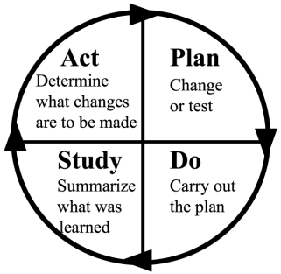

CCO recommends applying the Plan, Do, Study, Act (PDSA)³ cycle of continuous improvement for QIP development.

 | What happens in this part of the cycle?⁴ | Tips
Plan | - Create a baseline  - Define achievable goals  - Define data required to track and measure your goal and how it will be collected | - Keep things simple and manageable, and set small and achievable goals (e.g., focus on one patient sub-population in the first phase)
Do | - Put the plan into practice  - Collect data  - Record useful observations | - Ensure that data is collected and recorded consistently
Study | - Analyze the data collected to track progress  - Determine the next step needed to help meet the screening rate goal | - Set a timeline for progress checkpoints that are achievable and make sense for your practice
Act | - Make changes | - Make simple changes to help achieve goals (e.g., develop a list of frequently asked questions and develop responses that are shared with all practitioners who conduct ACP consultations with patients)
¹ 2013/14 Quality Improvement Plan Guidance for primary care organizations in Ontario. Available from: http://www.health.gov.on.ca/en/pro/programs/ecfa/legislation/qi_primary.aspx.
² CCO Internet, Prevention & Care, Screening, Breast Cancer Screening. Available from: http://www.cancercare.on.ca/pcs/screening/breastscreening.
³ Langley et al. 1996. Link available upon request.
⁴ National Academy for State Health Policy. PDSA Cycles. Available from: http://www.nashp.org/sites/default/files/abcd/abcd.ut.pdsa.cycles.definedsimple.pdf .
¹ 2013/14 Quality Improvement Plan Guidance for primary care organizations in Ontario. Available from: http://www.health.gov.on.ca/en/pro/programs/ecfa/legislation/qi_primary.aspx.
² CCO Internet, Prevention & Care, Screening, Breast Cancer Screening. Available from: http://www.cancercare.on.ca/pcs/screening/breastscreening.
³ Langley et al. 1996. Link available upon request.
⁴ National Academy for State Health Policy. PDSA Cycles. Available from: http://www.nashp.org/sites/default/files/abcd/abcd.ut.pdsa.cycles.definedsimple.pdf.

Section 1: Instructions

1.1 Plan
Your practice should begin by creating an ACP improvement plan. There are five simple steps involved in this process.
Five-Step Plan Checklist:
- 1. Identify team members
- 2. Fill out the Planning Tool (Section 2)
- 3. Fill out Part A of the Measurement Tool (Section 3)
- 4. Orient primary care providers, healthcare professionals and other staff who will be involved in the initiative
- 5. Make staff and patients aware of initiative
1. Identify team members
Identifying who will be involved and ensuring that they are properly oriented is a key to successful implementation. The practice will need to:
- Select a lead coordinator to act as main point of contact
- Ensure that there is enough staff support to carry out the initiative
- Identify who will be conducting ACP consultations (e.g., primary care providers, nurses, other healthcare professionals)

2. Fill out the Planning Tool
The Planning Tool (Section 2) provided by Cancer Care Ontario is a step-by-step planning guide. It will help your practice identify its goals, measurement plan, and approach for change implementation for the initiative. In Appendix A, you will find a workflow diagram outlining the proposed Advance Care Planning process and instructions to guide you through each part of the process. Appendix B contains a list of useful resources.
3. Fill out the Measurement Tool
Once you have defined the criteria for your target patient population, you will be able to run a report using your Electronic Medical Record (EMR) of patients who meet the criteria. Develop a system of tracking patients who have had an Advance Care Planning consultation.

NOTE: It is important to be consistent when developing measures and tracking progress. All primary care providers, healthcare professionals and staff involved should be trained to follow a consistent methodology. Your practice can decide what data source is used; the following are some examples:
4. Orient staff directly involved
Once you have filled out the Planning Tool (Section 2), it is important to hold an orientation session for primary care providers, healthcare professionals and other staff members directly involved in the initiative. Provide participants with this toolkit and build/formalize changes to current practice workflows to accommodate the new initiative.
5. Educate staff and patients indirectly involved
Hold staff meetings, send emails and post notices on staff bulletin boards to educate primary care providers, healthcare professionals and other staff who are indirectly involved in the initiative so that the QIP process runs smoothly.
Develop posters and stock the waiting room with ACP patient education materials. Communicating this type of initiative to patients will show them that your practice is proactive in delivering quality care and may even encourage them to raise the topic with their primary care provider. Please refer to the Appendix B for helpful resources.

1.2 Do
In the Do phase, you execute your plan.
Execute your planned activities. Throughout the process, your lead coordinator should supervise the initiative and provide timely responses to staff questions. Holding regular team meetings to track progress, troubleshoot challenges and celebrate successes are key to ensuring that the team stays engaged and motivated and that issues are addressed.

1.3 Study
There are three steps in the Study phase of the ACP QIP.
Three-Step Study Checklist:
- 1. Fill out Part B of the Measurement Tool (Section 3)
- 2. Review results with team
- 3. Share results with all primary care providers, healthcare professionals and other staff members

1. Fill out Part B of the Measurement Tool
Fill out Part B of the Measurement Tool (Section 3) periodically (e.g., every three months) to track your team’s progress.
2. Review results
Hold regular checkpoint meetings (e.g., every three months), where the Measurement Tool (Section_3) can be used to review outcome and process measures, and review progress made since the start of the initiative.
3. Share results
Results can be shared within the practice and patients to keep them informed of the initiative’s progress.

1.4 Act
Modify the plan, as appropriate, based on feedback from the Study phase. Make any necessary adjustments to the process and ensure that all involved primary care providers, healthcare professionals and other staff members are kept abreast of these changes.
At the end of the fiscal year, evaluate the quality improvement initiative.
- Take your final measures and complete Part C of the Measurement Tool (Section 3) to determine whether your practice achieved its target rates of ACP consultations and education sessions.

- Get feedback from primary care providers, healthcare professionals, other staff and patients who were involved in the initiative regarding:
  - What went well
  - What challenges/difficulties were encountered
  - What could be done differently
Staff can evaluate the initiative through online or paper surveys. Selected patients can complete the evaluation through a patient satisfaction survey (which could be included in a patient package) or through documented verbal discussions.

Section 2: Planning Tool
This Planning Tool is intended to support the development of your practice’s ACP Quality Improvement Plan (QIP) and is to be used in conjunction with the accompanying Instructions document.

As you fill out this step-by-step tool, please refer to the sample completed ACP QIP below. 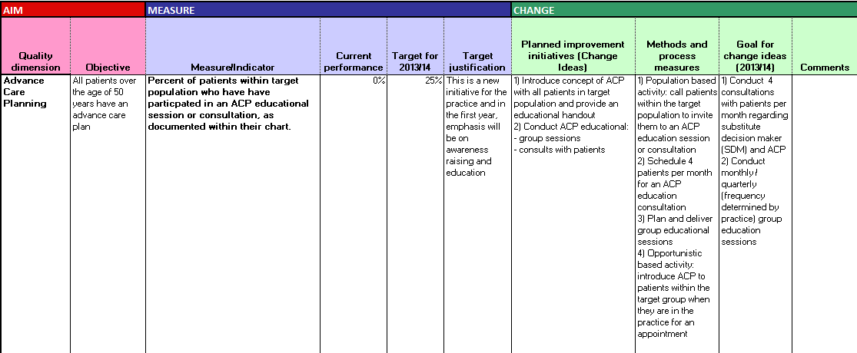
4
5
6
1
2
3

Step
AIM | Identify the objective and measure  1  /indicator | This will form the basis of all of your activities. The indicator selected should be detailed and the methodology of measurement should be clearly identified. | State the objective of this initiative (e.g., All patients over 50 years an advance care plan):
AIM | Identify the objective and measure  1  /indicator |  | List measure(s)/indicator(s) (e.g., percent of patients within the target group who have):  - A flag on their chart to identify that they  are within target group  - Documented on their chart to identify that they:  - Have received information (eg ACP patient package) about ACP  - Have attended an ACP educational session  - Have received an ACP consultation  - Confirmed that they have engaged in ACP
AIM | Identify the objective and measure  1  /indicator |  | Identify methodology (e.g., numerator: number of patients within the target population who have (see each measure above) / denominator: total number of patients in the target group):
MEASURE | Establish a baseline for performance  2 | Using the measure or indicator outlined in Part 1, identify the practice’s baseline by running a report/query in your EMR. Record the baseline in both the QIP and the Measurement Tool. NOTE: It is important to be consistent when developing measures and tracking progress. All impacted primary care providers, healthcare professionals and staff should be trained on following a consistent methodology. Your methodology has to be consistent but not perfect. | Identify baseline (for each indicator identified):  Describe the method for baseline calculation (for each indicator identified) and data sources used:
MEASURE | Identify what your target(s) for year will be  3 | Your targets should be achievable with a bit of a stretch component, but not unattainably high. | Identify the target for each of the indicators selected:  - E.g. Educate 50% (target to be set by practice)of the patients within the target group about advance care planning through group ACP education sessions
 | Identify what your target(s) for year will be  3 |  | Describe target justification, including assumptions and adjustments:  - E.g. Education process takes time so some patients may initially be resistant to developing an advance care plan
CHANGE | Decide on what changes the practice will make to current workflows in order to achieve the goal  4 | Depending on your practice structure and supports available, some activities that could be implemented include:  - Run an EMR query to generate a list of your patient population that you will target for this initiative (Note: this may be done in phases)  - Create patient education handouts and packages to support your initiative (you may choose to use the patient handout tool developed by Advance Care Planning in Canada - Appendix F )  - Develop a script with key messages for primary care providers and other health care professionals within your practice who will be having conversations about ACP with patients and provide appropriate training (you may choose to use the practitioner tool found at Advance Care Planning in Canada – Appendix G)  - Assign a health care professional(s) on your team to conduct ACP education consultations with patients and provide them with the patient packages (you may choose to use the handout on Substitute Decision Makers and Power of Attorney for Personal Care, the template “Thinking About my Wishes for Future Health Care” and the Advance Care Planning Workbook: Ontario Edition found at Advance Care Planning in Canada  - Determine where in the chart to document that patients have received education re ACP  - NOTE: Refer to Appendix A for an overview of the ACP process and Appendix B for support resources | List the activities that your practice will be implementing:
 | Identify how changes will be implemented and identify process measures  5 | This section identifies the activities and process measures that the practice will be implementing and the targets for each measure. | List process measure(s) for the activities identified in Part 4:  - E.g. Schedule 4 (target to be set by practice) appointments per month for patients within the target population to attend an ACP education consultation  - Schedule group educational sessions
 | Goal for change ideas  66 | Identify the goals that the practice is aiming to achieve based on the process measures. These should tie back to the overall objectives of the initiative. | Identify goal(s):  - Conduct 4 (target to be set by practice)consultations with patients per month regarding SDM and ACP

Section 3: Measurement Tool

Part A: Performance Measurement Planning
Identify the indicators and process measures for your initiative and fill out tool below. For each indicator, identify the baseline/current value. Below find some examples of possible indicators, methodologies and baselines.

1. Indicator Selection
-What is/are the indicator(s)/outcome measure(s) of this initiative?
-How is/are the indicator(s)/outcome measure(s) going to be calculated?
-What is the baseline?
Indicator(s) | Methodology | Baseline Value | Target Values
e.g., Percentage of the target population who have been invited to attend advance care planning educational session as documented in their chart | Numerator: (E.g., number of patients who have been invited to attend group educational session or advance care planning consultation)  Denominator: (E.g., total number of patients identified within the target population and invited to consult)  Note: Practice to determine the measure methodology | E.g., 50 patients/400 total patients who fall within the target population= 12.5% | (as stated in QIP)  E.g. 25%
 |  |  | (as stated in QIP)
 |  |  | (as stated in QIP)

2. Process Measure Selection
Process Measure(s) | Methodology
e.g., Patient response rate | e.g., Number of patients who:  Schedule an appointment for ACP education

3. Period Duration
-How often will the checkpoints occur (e.g., every quarter/month/week)?

Part B: Periodic Checkpoint Review (to be filled out routinely)
Period: (e.g., May 1st–June 1st)
1. Indicator Evaluation
Indicator(s) |  | Period-End Result |  | Change from Baseline |  | Change from Last Period
e.g., Percentage of patients in the target population who have  - attended an educational session |  | Numerator: Patients who have completed a consult for advance care planning (add: patients who are part of the baseline+ patients who completed a consult for advance care planning since the day of baseline measurement and checkpoint review)  Denominator: Total pool of patients within the target group  E.g. 50 patients at baseline + 20 additional patients who completed a consult for advance care planning since the baseline measurement/400 total patients in target population = 17.5% |  | e.g., 17.5% – 12.5%=+5.0% |  | e.g., N/A
2. Process Measure Evaluation
Process Measure(s) | Current Value |  | Change from Last Period |  | Interpretation  (this section will inform the Period Analysis)
e.g., Percentage of patients within the target group who have scheduled an appointment for an ACP education consultation | e.g., Only 10% of patients in the target group have attended an ACP education consultation |  | e.g., N/A |  | e.g., Patients may not see it as a priority

3. Period Analysis
-Overall, how is the practice performing?
-What issues have arisen? What is the issue mitigation plan?
-E.g. Issue: Patients not seeing ACP as a priority
Mitigation Plan: Schedule group education workshops once per month and send out invitation letters to patients in the target population to attend

Part C: Final Evaluation
To be conducted in preparation for submission of final QIP report and to plan for next period.
1. Indicator Evaluation
Indicator(s) |  | Period-End Result |  | Change from Baseline |  | Change from Last Period
e.g., Percentage of patients in the target population who engaged in advance care planning |  | (Use methodology outlined above to calculate this) |  | (Calculate current period percentage and subtract baseline value) |  | (Calculate current period percentage and subtract from previous period percentage)
2. Process Measure Evaluation
Process Measure(s) | Current Value |  | Change from Last Period |  | Interpretation  (this section will inform the Period Analysis)
e.g., Percentage of patients in target population who attended a ACP meeting | Use same methodology as previous periods |  | Subtract current period performance from previous period performance |  | (Interpret results)

3. Final Period Analysis
-How did the practice perform over the final period?

4. Final Review of Initiative
-How did the practice perform over the entire initiative?
-Were targets achieved?
-What successes were achieved?
-What issues arose? How were they mitigated/addressed? How successful were the plans to address the issues?

Section 4: ACP Sample QIP Timeline

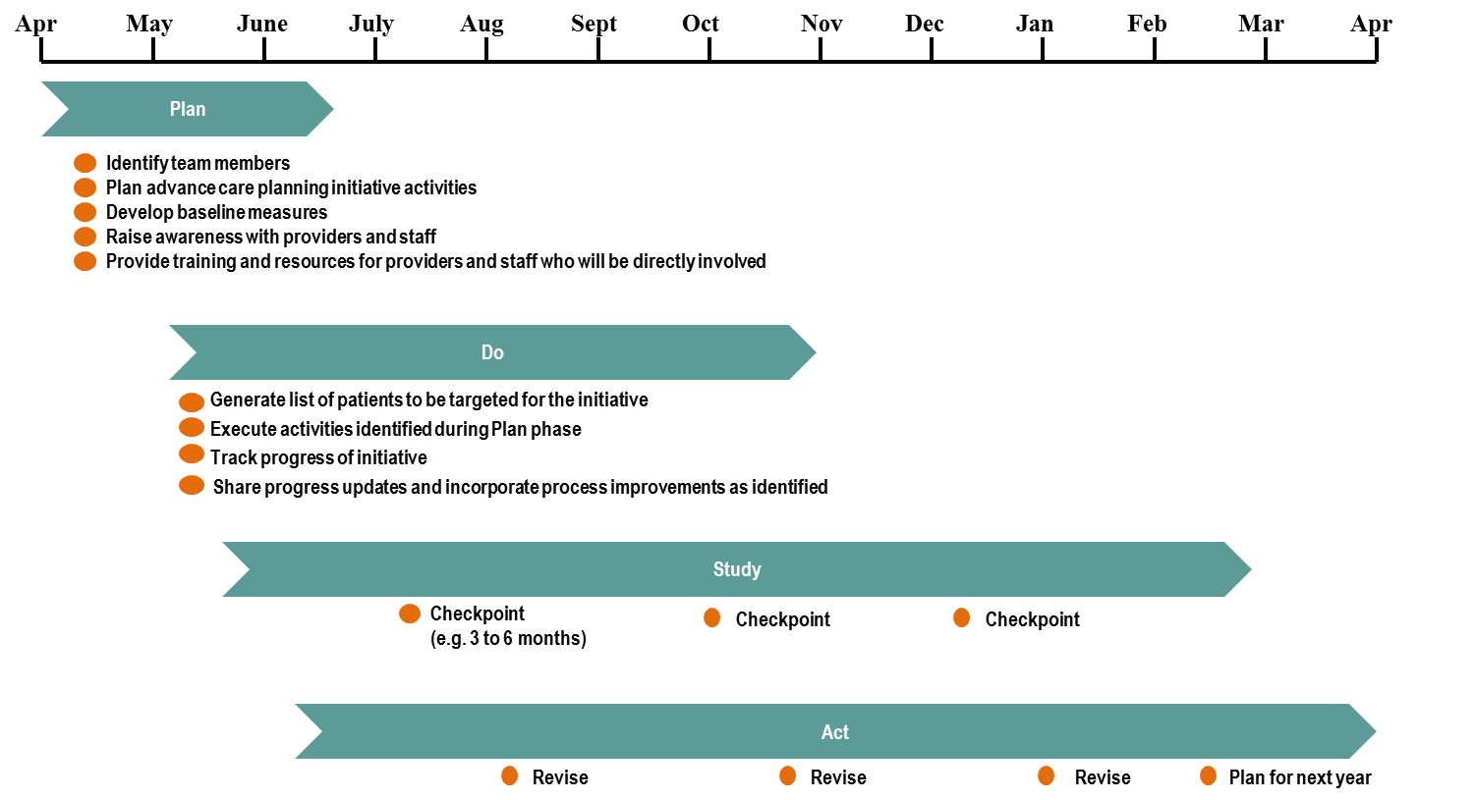
Appendix A: Supporting patients through Advance Care Planning in Ontario
Part 1 (NOTE: This sample workflow is to be used in conjunction with Steps in Part 2):
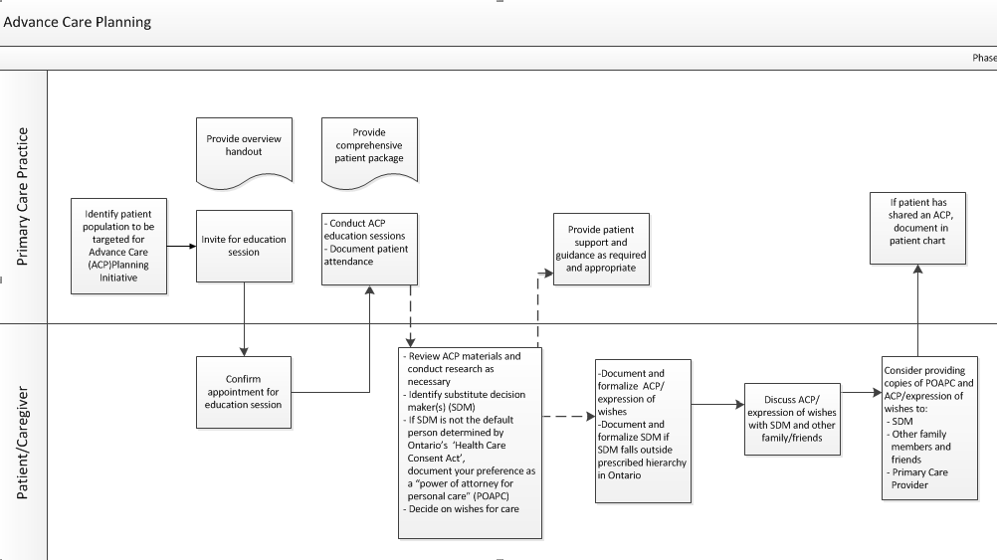
1
2
3
4
5
Appendix A: Supporting patients through Advance Care Planning in Ontario
Part 2 (NOTE: This section outlines suggested steps in implementing an Advance Care Planning initiative within your practice and is to be used in conjunction with the Advance Care Planning Workflow diagram in Part 1):
Steps:
- 1. Identify patients within your practice to target for advance care planning initiative
- 2. Invite them to attend an ACP education consultation
- 3. Conduct ACP consultation with patient
- 4. Provide support and guidance as required
- 5. Conduct meeting to review final ACP plan with patient and substitute decision maker (SDM)
1
1. Identify patients within your practice to target for the ACP initiative
- Your practice may identify several patient sub-populations that might be appropriate for the ACP initiative and choose to start with one sub-population using the Plan, Do, Study, Act (PDSA) cycle before expanding the initiative to other sub-populations. For example, you might target:
- All patients with end stage organ disease, cancer and other serious illnesses OR
- All patients over a certain age (e.g. you may choose to focus on all patients over 65 years of age).
You can also refer to the Respecting Choices Program which describes Advance Care Planning with three different populations (http://www.gundersenhealth.org/respecting-choices)

- You can create searches within your Electronic Medical Record (EMR) to identify the patient population targeted for the ACP initiative

2
Invite patients to attend an ACP educational session

- The primary care provider can introduce the topic of advance care planning (ACP) when a patient within the target population attends an appointment (Refer to Primary Care Toolkit – Patient FINAL link in Appendix E)
- Provide the patient with a one page overview document in preparation for the education consultation (Refer to Patient handout link in Appendix E) and the handout on Substitute Decision Makers and Power of Attorney for Personal Care (Refer to link in Appendix E)
- Conduct a group patient education session facilitated by a provider within your practice for patients within your target population.
3
Conduct educational ACP session

- Designate healthcare practitioner(s) to conduct ACP consultations with patients (i.e. the team may choose to have this done by another member of your team such as a Nurse Practitioner or Social Worker)
- Provide training and resources required to conduct the consultation (Refer to Provider Handout, Patient Handout, Patient Package link in Appendix E)
- Create patient packages containing:
  - Patient information on the ACP process in Ontario (Refer to XX document, link in Appendix E)
  - Template for “Thinking About My Wishes for Future Health Care” (link in Appendix E)if your practice uses the form
  - Information on other resources
- Provide information on how to patient can request support from practice
- Schedule date for follow up meeting if required
- Document patient attendance at educational session
4
Provide follow up support and guidance as required
5
If patient has shared an ACP, for education session document in patient chart

Appendix B: Sample Advance Care Planning Templates

In this appendix you will find links to sample templates that can be used in the process of advance care planning. You may choose to adopt them for use in your practice or to create your own. As you decide what would work best for your practice, please keep in mind the requirements for Advance Care Planning in Ontario (refer to Appendix C).

- “Thinking About My Wishes for Future Health Care” template (link)

You may find it useful to use this with the Advance Care Planning Workbook: Ontario Edition
This workbook provides Ontario patients and families with a guide to doing advance care planning. It was developed in partnership between Advance Care Planning in Canada (Canadian Hospice Palliative Care Association) and the Ontario Hospice Palliative Care Association.

This workbook can be downloaded for free from http://www.advancecareplanning.ca/making-your-plan/how-to-make-your-plan/provincial-territorial-resources/advance-care-planning-workbook-ontario-version.aspx

Hard copies are available from Hospice Palliative Care Ontario for $5.00 by contacting alecoche@hpco.ca or 1-800-349-3111 ext 22.

- American Family Physician (AFP) is a semimonthly, peer-reviewed journal of the American Academy of Family
http://www.aafp.org/afp/1999/0201/p617.html

- Other Canadian resources
Other jurisdictions have also developed templates and workbooks. Remember, these may not be congruent with the legal framework for advance care planning in Canada. These resources can be found at:
http://www.advancecareplanning.ca/making-your-plan/how-to-make-your-plan/provincial-territorial-resources/advance-care-planning-workbook-ontario-version.aspx
Appendix C: Advance Care Planning Requirements in Ontario*
In Ontario you can CHOOSE someone (or more than one person) to be your Substitute Decision Maker(s) by preparing a Power of Attorney for Personal Care.

If you have not signed a Power of Attorney for Personal Care, the law in Ontario provides that you will always automatically have a Substitute Decision Maker for health care. There is a ranking list of Substitute Decision Maker(s) – and the person or persons in your life that are the highest ranked in this list and meet the requirements to act as a Substitute Decision Maker will be your Substitute Decision Maker(s) for health care. For example, this might be your spouse or your child/children. Ask your doctor or nurse practitioner for a copy of this list or you can find it at www.advancecareplanning.ca in the Advance Care Planning Workbook: Ontario Edition (Refer to link in Appendix E).
[Hyperlink http://www.advancecareplanning.ca/making-your-plan/how-to-make-your-plan/provincial-territorial-resources/advance-care-planning-workbook-ontario-version.aspx]

If you want someone other than the first person at the top of the list to make decisions on your behalf – you must complete a Power of Attorney for Personal Care to appoint that person.

Power of Attorney for Personal Care

A Power of Attorney for Personal Care is a document, in writing, in which you name someone to act on your behalf and have the legal authority to do so.

To be legal, the document must be signed by:
- You, in the presence of two witnesses;
- The two witnesses in front of you. (Witnesses cannot be your spouse, partner or child.)
- You must sign it of your own free will.

You must be mentally able to understand what you are signing and what you are doing by signing such a document.

Your Substitute Decision maker must be mentally capable and at least 16 years old. He or she must be available and willing to take on this task. There must not be any legal reasons stopping him or her from doing this.

You do not have to see a lawyer to do a Power of Attorney for Personal Care – of course you can if you prefer. You can get the form to fill out from our office or from the Government of Ontario at 1-800-366-0335 or http://www.attorneygeneral.jus.gov.on.ca.
*Source: Advance Care Planning Workbook: Ontario Edition. Speak Up: Start the Conversation about end-of-life care. http://www.advancecareplanning.ca/making-your-plan/how-to-make-your-plan/provincial-territorial-resources/advance-care-planning-workbook-ontario-version.aspx

Appendix D: Word List/Glossary**
By learning more about common end-of-life terms and treatments, you can develop an Advance Care Plan that truly reflects your wishes. You may also wish to include some of these terms in your Advance Care Plan:
Allow natural death refers to decisions NOT to have any treatment or procedure that will delay the moment of death. It applies only when death is about to happen from natural causes.
Cardiopulmonary resuscitation (CPR) refers to medical procedures used to restart your heart and breathing when the heart and/or lungs stop working unexpectedly. CPR can range from mouth-to-mouth breathing and pumping of the chest to electric shocks that may restart the heart and machines that breathe for the individual.
Comfort measures are treatments to keep you comfortable (e.g., pain relievers, psychological support, physical care and oxygen).
Dialysis is a medical procedure that cleans your blood when your kidneys can no longer do so.
End-of-life care refers to health care provided at the end of a person’s life. This type of care focuses on you living the way you choose during your last days or weeks and providing comfort measures until the time of death.
A feeding tube is a way to feed someone who can no longer swallow food.
Health care professional is a person licensed, certified or registered in their province/territory to provide health care (e.g., a doctor, nurse or social worker).
Informed consent refers to the permission you give to health care providers that allows medical investigations and/or treatments. Health care providers are required to offer you, and you are entitled to receive, detailed explanations of the investigations/treatments and their risks, benefits and side effects; alternatives to these options; and what would likely happen if you refuse the options. They must also answer any questions you have about the treatments and the information must be provided before you give verbal consent or sign a consent form.
Intravenous (IV) is a way to give you fluids or medicine through a vein in your hand or another part of your body.
Life support with medical interventions refers to medical or surgical procedures such as tube feeding, breathing machines, kidney dialysis, some medications and CPR. All of these use artificial means to restore and/or continue life. Without them, you would die.
Life limiting illness refers to an incurable medical condition caused by injury or disease.
Palliative care is the way we care for people who have a life limiting illness. It focuses on providing good quality of life, in other words, keeping you as comfortable and free of pain or other symptoms as possible. Palliative care may involve medicines, treatments, physical care, psychological/social services and spiritual support, both for you and for those who are helping to care for you. Palliative care can be provided anywhere, at any stage of any illness along with care and treatment aimed at cure or prolonging life.
Power of Attorney for Personal Care is a document in Ontario that you prepare when you are mentally capable to name a person or persons to be your Substitute Decision Maker for health and other personal care decisions. That person or persons would make decisions about treatment and health care on your behalf if you become mentally incapable.
Substitute Decision Maker (SDM) is a person(s) who provides consent or refusal of consent for treatment or withdrawal of treatment on behalf of another person when that person is mentally incapable to make decisions about treatment. The Substitute Decision Maker(s) is required to make decisions for you following any wishes you expressed about your care when you were mentally capable. If your Substitute Decision Maker does not know your wishes applicable to the treatment decision to be made, he or she is required to act in your best interests.
Symptoms are signs that you are unwell (e.g., pain, vomiting, loss of appetite or high fever).
Terminal illness means an incurable medical condition caused by injury or disease. These are conditions that, even with life support, would end in death within weeks or months. If life support is used, the dying process takes longer.
A ventilator is a machine that helps people breathe when they cannot breathe on their own.
**Source: Advance Care Planning Workbook: Ontario Edition. Speak Up: Start the Conversation about end-of-life care. http://www.advancecareplanning.ca/making-your-plan/how-to-make-your-plan/provincial-territorial-resources/advance-care-planning-workbook-ontario-version.aspx

Appendix E: Listing of Resources
While there are common elements in the advance care planning (ACP) process across Canada, many of the resources that are found in Appendix B highlight specific aspects of ACP in Ontario to assist you in supporting your patients through this journey:

- CCO website for toolkit – Toolkit link

- ACP resources created by CHPCA: written intro to give patients, information for providers, generic Substitute Decision Maker and Advance Care Plan Note (Ontario specific)
  - Patient handout created by CHPCA
  - Provider tool created by CHPCA
  - Your Substitute Decision Maker and Power of Attorney for Personal Care
  - ACP template form create by CHPCA
  - Glossary of terms for patients
  - Poster

- Advance Care Planning in Canada/Speak Up: Start the conversation about end-of-life care

Advance Care Planning in Canada is a national initiative that provides resources for individuals, communities and health care providers about Advance Care Planning. It is facilitated by the Canadian Hospice Palliative Care Association (CHPCA). There are many resources on the website www.advancecareplanning.ca

Resources are organized specific to the province or territory.
http://www.advancecareplanning.ca/making-your-plan/how-to-make-your-plan/provincial-territorial-resources.aspx

Of particular value is the Advance Care Planning Workbook – Ontario Edition. This workbook has been developed in partnership with Hospice Palliative Care Ontario. It enables patients and families to explore their values and express their wishes for care.
http://www.advancecareplanning.ca/making-your-plan/how-to-make-your-plan/provincial-territorial-resources/advance-care-planning-workbook-ontario-version.aspx] This Workbook can be downloaded for free at the above link. Hard copies are available from Hospice Palliative Care Ontario for $5.00 by contacting alecoche@hpco.ca or 1-800-349-3111 ext 22.

ACP in Canada has implemented a campaign entitled Speak Up: Start the conversation about end of life care. This campaign is intended to raise awareness among the public and professionals regarding advance care planning. Speak Up has a Campaign Toolkit with many resources that can be used to increase awareness and educate your community about ACP. Access the Campaign Toolkit here.
http://www.advancecareplanning.ca/community-organizations/download-the-speak-up-campaign-kit.aspx

ACP in Canada has developed two ACP tools – one for patients and families and one for professionals – specifically for patients with a cancer diagnosis. They were developed as a partnership between the Advance Care Planning in Canada initiative, the BC Cancer Agency and members of the BC Patient Voices Network. Cancer and Advance Care Planning – This tool for patients and families describes the process of advance care planning and why it is important; issues to consider around their diagnosis and treatment plan; and lead them to other resources. Cancer and Advance Care Planning: Tips for Oncology Professionals – This tool for oncology professionals provides practical suggestions for when to have the discussion, with specific conversation starters that can help professionals get started. It also includes the rationale for advance care planning with references to the relevant literature.
Download them here.
http://www.advancecareplanning.ca/community-organizations/download-the-speak-up-campaign-kit/bc-cancer-toolkit.aspx

- Ontario Seniors Secretariat
The Ontario Seniors’ Secretariat has developed a comprehensive Guide to Advance Care Planning (also available in Chinese) and a wallet card to document that you have done this and the contact of your Substitute Decision Maker

http://www.seniors.gov.on.ca/en/advancecare/

- Canadian Virtual Hospice
The Canadian Virtual Hospice provides support and personalized information about palliative and end-of-life care to patients, family members, health care providers, researchers and educators.
http://www.virtualhospice.ca/en_US/Main+Site+Navigation/Home.aspx
- Ontario Attorney General
The Office of the Public Guardian and Trustee has a Power of Attorney Kit that will help you appoint the person you want to make decisions for you when you are no longer able to do so for yourself.

http://www.attorneygeneral.jus.gov.on.ca/english/family/pgt/poa.pdf

- Hospice Palliative Care Ontario
Hospice Palliative Care Ontario (HPCO) provides leadership on behalf of their members by informing policy and promoting awareness, education, knowledge transfer and best practices in the pursuit of quality hospice palliative care in Ontario. The membership includes 170 organizations and 500 individual members providing high quality hospice palliative care in Ontario., representing a range of stakeholders from all aspects of hospice palliative care. HPCO coordinates Speak Up Ontario! which is a network of advance care planning champions who provide ACP education within their LHIN regions. For more information regarding Speak Up Ontario! and the champions in your region contact Anna LeCoche at alecoche@hpco.ca.

- Canadian Hospice Palliative Care Association
Canadian Hospice Palliative Care Association provides an advance care planning resource commons searchable to the provincial level for patients and families, professionals (health, legal, planning) and communities.

http://www.chpca.net/resource-commons/advance-care-planning-resource-commons.aspx

- Respecting Choices
An American program that suggests three levels of Advance Care Planning depending on the person’s health status.

http://www.gundersenhealth.org/respecting-choices

- American Family Physician (AFP)
AFP is a semimonthly, peer-reviewed journal of the American Academy of Family Physicians
http://www.aafp.org/afp/1999/0201/p617.html

Appendix F: Initial Patient Information Handout

Talk to your doctor or nurse practitioner about
Advance Care Planning
What would happen if you were sick or injured and could not tell doctors what kind of care you wanted? Who would speak for you and make decisions for you?
What is Advance Care Planning?
It’s thinking about what is important to you if you were sick or injured and could not speak for yourself. You need to decide who would make decisions for you – and tell them what kind of care you would want.
Why should you do it?
It can be very hard for others to have to make decisions for you if they do not know your wishes. You need to tell others what you want and do not want if you could not speak for yourself.
How do you do it?
You need to decide who will be your Substitute Decision Maker – the person who would talk for you if you cannot talk for yourself – and talk to them about your wishes. You can also write down your wishes, or make a recording or video. There are workbooks at: advancecareplanning.ca
Who should do it?
Everyone should do advance care planning.
When should you do it?
As soon as possible. Do it when you are healthy. Always take time to think about it again when things change in your life.
Find out more:
Ask your Doctor or Nurse Practitioner about Advance Care Planning
Visit: www.advancecareplanning.ca

Download the Speak Up: Advance Care Planning Workbook – Ontario Edition.
Appendix G: Provider Resource, Approach and Phrasing

Why should you talk to your patients about
advance care planning
- You have a longstanding relationship with your patients and they trust you. This allows you to initiate the discussion and help educate them about the importance of advance care planning.
- You have knowledge and expertise about their illness.
- Research shows us that advance care planning
  - Improves quality of life and quality of end-of-life care.
  - Reduces stress and anxiety for patients, families and caregivers.
  - Improves communication between patients, families and the health care team.
  - Reduces strain on the health care system.

Advance Care Planning is a process of reflection and communication. It is a time for patients to reflect on their values and wishes, and to let others know what kind of health and personal care they would want in the future if they became incapable of consenting to or refusing treatment or other care. It involves having discussions with family and friends – especially their Substitute Decision Maker(s) – who is the person or people who will provide consent or refusal of consent for care and treatment if the patient is incapable.
Practical Suggestions
- Introduce the topic of advance care planning to all patients over 50 years of age. Also to all patients with end stage organ disease and cancer.
- Use the scripts below to start the conversation.
- You will probably need to make a second appointment to discuss this in more detail. Ask your patient to bring their Substitute Decision Maker to that appointment. Allow time for reflection and decision-making.
- Refer patients to the Speak Up: Advance Care Planning Workbook – Ontario Edition – to help them explore their values and wishes.
- Utilize the template, “Thinking about my wishes for future health care”. Make sure the patient and their Substitute Decision Maker have copies. And that there is one in their chart.
- Make this a practice wide initiative by involving other healthcare professionals and practice staff.

Here are some suggested phrases for introducing the topic to your patients.
- You are well now, but it is good to plan for the future. What if you suddenly became very ill or had an accident – and couldn’t speak for yourself?
- The best time to think about advance care planning is when you are well and are able to make decisions in a calm state of mind.
- If you were to get very sick and could not speak for yourself, who would you trust to make medical decisions for you?
- I’d like to talk to you about your wishes for care in case you get very sick. That might not happen, but if it does and you can’t communicate, it would be important to know who would speak for you and about your wishes for care.
- Advance care planning is similar to writing your will. It is good to be prepared and let your wishes be known.
- I want to give you the best care possible. Talking about your wishes will help me do that.
Acknowledgements
The primary care team at Cancer Care Ontario would like to thank Louise Hanvey, Director of Advance Care Planning in Canada, Speak Up: Start the conversation about end-of-life care, Canadian Hospice Palliative Care Association and Dr. Daren Heyland, Professor of Medicine, Queen’s University
Director, Canadian Researchers at the End of Life Network (CARENET).

They have both been wonderful collaborators and supported CCO in the development process of the ACP toolkit and the many supporting documents that we hope you will find useful.

The primary care team at Cancer Care Ontario would like to acknowledge the collaboration of Louise Hanvey, Director of Advance Care Planning in Canada, Speak Up: Start the conversation about end-of-life care, Canadian Hospice Palliative Care Association and Dr. Daren Heyland, Professor of Medicine, Queen’s University, Director, Canadian Researchers at the End of Life Network (CARENET).

